**Software Requirement Specification**

A Project

On

**“WEB BASED UNIVERSITY MANAGEMENT SYSTEM”**

Submitted by

**YASHASHVI THAKUR**

**PRN - 220960820071**

**PG-DAC**

**SEPTEMBER 2022**

**Centre for Development of Advanced Computing**

**(A Scientific Society of the Ministry of Communications and Information Technology, Govt. of India)**

**No 4, Rajiv Gandhi Salai,**

**Tidel Park**

**Taramani, Chennai – 113**

**Table of Contents**

**1. Introduction 3**

1.1 Purpose 3

1.2 Document Conventions 3

1.3 Intended Audience and Reading Suggestions 3

1.4 Project Scope 4

1.5 References 4

**2. Overall Description 4**

2.1 Product Perspective 4

2.2 Product Features 5

2.3 User Classes and Characteristics 5

2.4 Operating Environment 5

2.5 Design and Implementation Constraints 6

2.6 User Documentation 6

2.7 Assumptions and Dependencies 6

**3. System Features 7**

**4. External Interface Requirements 7**

4.1 User Interfaces 7

4.2 Hardware Interfaces 7

4.3 Software Interfaces 7

4.4 Communications Interfaces 8

**5. Other Nonfunctional Requirements 8**

5.1 Performance Requirements 8

5.2 Safety Requirements 8

5.3 Security Requirements 8

5.4 Software Quality Attributes 9

**6. Other Requirements 8**

**Appendix A: Glossary…………………………………………………………………………….10**

Definitions………………………………………………………………………………….10

Abbreviations........................................................................................................................10

**Appendix B: Analysis Models…………………………………………………………………...12**

**1. Introduction**

* 1. **Purpose**

The main objective of this web based university management system is to maintain information about the students data, students forms, fee payments, enrolments, exam results, notifications or notices etc. for proper functioning as well as maintaining the database for the university and to showcase various achievements for admission adherences for the university.

A web based university management system which is a digital solution for helping in automation of the tasks that will provide access and management of information of different modules in a university like Students, Teachers / Staff, Finance, Examination, HR etc. This project is based on the database, which stores, manage as well as retrieve the information provided by the different modules of the university management system. The advantage of this web based management system is to avoid entries of the hard copies and to save the burden of stories the data in hard copies for an easy management of resources. It is a web based management system created through the use of Html, CSS and JavaScript. The database for this management system is created in MYSQL. There are two users for this management system – 1. Admin (Will have full access to read, write and execute), 2.Student (Will have read and write access only). This is version 1.0 of university management system.

* 1. **Document Conventions**

This software requirement specification is being written in font “Times New Roman” with the font size of 12. Headings are kept in bold letters with font size 14 and font style “Times New Roman”.

**1.3 Intended Audience and Reading Suggestions**

This document is to be read by the development team, the project managers, marketing staff, testers, and documentation writers. The software engineer/Developer and project managers need to become intimately familiar with the SRS. Others involved need to review the document.

Testers need an understanding of the system features to develop meaningful test cases and give useful feedback to the developers. The developers need to know the requirements of the software product they need to build.

This document is for general discussions on the implementation decisions regarding the University Management System. The user of the product should be known to the concept of Web development, MySQL for database, And Java for Backend programming.

## 1.4 Project Scope

As Universities are growing day by day, and also increasing the complexity of storing information of students and related to the university system, they face many related issues like students admission form management, exam data collection, fees collection, issuing notices and promoting admissions etc. This project is based on the educational institute system where this application gives maximum services in a single website that is used by system administrator as well as by the students to fill forms, make payments, get results online etc. This project includes Web development technologies like Html, CSS, JavaScript and MySQL. Java is used to design the GUI for the application by which the user can interact with the websites. MySQL is used for creating the database in which different information will store and can be retrieve when needed. The main focus of this project is to give the best GUI for the users and provide the many modules in a single website program.

**1.5 References**

References were taken for developing this system requirement specification is from the internet, through instructor, IEEE recommended practise for Software Requirement Specifications, IEEE 830-1998 standard for writing SRS document.

**2. Overall Description**

**2.1 Product Perspective**

Manual University management systems were paper-based and difficult to maintain, expensive, more manpower required and unable to handle large records, the previous system was not efficient, not effective and there were issues of redundancy and consistency.

To overcome this problems and for better relevance and promotions of admissions, this web based university management system is being created. This management system not only manages the huge amount of student as well as faculties data but also give students to work digitally like to fill up the various forms like exam form, enrolment form, admission form without any difficulties from their respective areas sitting in the home, also payment of fees is done online so that students will not have to stand in long lines for payments and various notice and announcements are also obtained through this website.

Overall a perfect website where though admin section, every faculty can upload student attendances, marks, results, conducts online tests, time tables and syllabus papers etc. It is a digital solution in today’s world where everything is going digital. It gives an upper hand to the University for Proper Management i.e. storing, retrieving and executing the data’s and advertisements for the sake of admissions which leads to economic growth of the respective university.

**2.2 Product Features**

This web based university management system have a attractive web portal in which various sections, tabs and announcements or notices are given with login pages for the respective users i.e. there are two type of login users :

1. Admin

( This user type will have full access of the web portal from which university head, faculty/staff will login , Which will upload notices, announcements, advertisements, various student data’s like course offered, subject curriculum, syllabus, attendances, test marks, results, exam schedules etc.)

1. Students

(This user type will have only limited access i.e. can write only in forms, else only can read the data’s uploaded by the Admin.)

**2.3 User Classes and Characteristics**

This management system is controlled by the system administrator (Admin) i.e. through university head, faculty/staff. In this university management system, admin is the main user who has full access to the management system .admin can view and modify all information that is stored in the database. Admin can view and modify the student’s records like student’s profile, attendance, fee, results, and announcements and notices of the university, their personal information and their point of advertisements. Admin have the permission to approve the student’s admission forms and write the student’s information like their attendance, marks of exams to generate the progress report of students. When the teacher “update’s the student’s information like marks, attendances etc then students can view this information with their respective logins.

The second user i.e. students have the access to view their respective marks, attendance, results etc. through their login ids and passwords.

And the features or tabs in the websites like promotions, notices, announcements, time tables, syllabus, and courses offered etc. can be seen by any other person through web address. And can apply for the admissions of various courses offered by the university by creating login id and password first then filling up the form and on filling up, the respective form will first be reviewed by the admin user and if all the details uploaded are under their criteria of the students admission rules for respective course then the form will get verified by the admin user, and the respective user will become second user type i.e. student and can have second user access.

**2.4 Operating Environment**

The Web Based University Management System is expected to be deployed in a real environment to manage the DBMS inside the university. The centralized database is used to store the information. The user only within the admin (head or members of university staff) can use this university management system for database management. Second type of users is Students who have access to login and read only their respective details. Users outside from this two users can only read access on the web portal and write access only in the case of filling up of admission forms. This website is developed in windows operating system and can be available in any operating system through various famous browsers like Microsoft Edge, Google Chrome, Mozilla Firefox, Safari etc.

The database is used in two user type within a branch of the university. The database used to store the information is the centralized database through the use of IDE i.e. eclipseIDE 2022-09 for MySql linking and Core Java as backend technology with Html, CSS, JavaScript, and Bootstrap for frontend development of the web based management system.

**2.5 Design and Implementation Constraints**

* The data of all the users i.e. Admin and Students must be stored in the database that is accessible by the university website.
* MySQL is being used for storing the database of the users and IDE for connecting the database to the website.
* The Web based university management system is running 24 hours a day.
* Anyone can access the website from any computer or O.S. that has internet browsing capabilities and an internet connection.

**2.6 User Documentation**

The user profiles identifies to have interaction with the university management system web server is essentially to save the whole system information in sequentially into database server. The administration department will have access to whole system environment and that can modified as per the needs. The architecture of the whole system environment is made easy and user-friendly that any person can open the website and can login to the management system and use the functions. The system database is only accessible to the admin and admin can only modify the changes.

The user profiles identified to have interaction with Student Management System that anyone

can register and login into system and us the required resources. The students can easily fill up

the registration form online and submit it. And the admin will check the details that is the student

is eligible as per the admission criteria. After the student will successfully registered he can use

college/school system environments as per their limits decided by admin.

**2.7 Assumptions and Dependencies**

The web based university management system used the following third party products and skills:

1. JDK version 1.8 (Java Development Kit with Runtime Environment) installed for creating it.

2. MySQL (version 8.0.31) is used for storing the databases and IDE to connect it.

3. Html 5, CSS, JavaScript, Bootstrap skills and knowledge to develop and optimize a user friendly website.

**3. System Features**

In earlier time, the university was using the manual management system, which is based on the entries on the registers and documents. When a student or faculty/staff wants to view the data stored then they must have to do the entries in the resisters and help desk is also needed for it. To overcome the problem of manual university management system being paper-based with huge records storage and difficult to maintain, this web based university management system is being created.

Some of the important features of this web based management system are:

* The whole management system of records are being digitalized which can be easily created, retrieved as well as maintained.
* This system makes the handling of databases more efficient with less human resources, expenses, and makes it remotely accessible.
* The web page is also used for increasing of admissions for the university through various promotions, advertisements on the page etc as it is user friendly to its audiences.
* The issue of fee payments for the students standing in the long queues will get resolved as they can pay their respective courses fees remotely from their places through payment portal on the web.
* Various News, announcements as well as notices tabs leads to ensure that the audiences as well as students will get important information’s like admissions, exams, scholarships, fees etc.

**4. External Interface Requirements**

**4.1 User Interfaces**

The Web based university management system web server must be provide a user interface that will be accessible through any internet browser, the major ones being Google Chrome, Microsoft Edge, Mozilla Firefox etc. having internet connection on the device.

## Hardware Interfaces

All components able to be executed on personal computers with Windows OS platform and other platform like Linux, Unix etc.

## Software Interfaces

This Web page allows the user to interact with content or software running on a remote server through a Web browser. The content can be downloaded from the Web server and the user can interact with this content in a Web browser, which acts as a client.

## Communications Interfaces

Describe the requirements associated with any communications functions required by this product, including e-mail, web browser, network server communications protocols, electronic forms, and so on. Define any pertinent message formatting. Identify any communication standards that will be used, such as FTP or HTTP. Specify any communication security or encryption issues, data transfer rates, and synchronization mechanisms.

**5. Other Non-functional Requirements**

Non-Functional requirements may exist for the following attributes. Often these requirements must be achieved at a system wide level rather than at a unit level. The requirements are in following sections:

* 1. **Performance Requirements**

The web based university management system shall be built upon the web development technique and put on the web server online. The system and the server must be capable of handling the real-time error functionality occurs by the defined users. In addition, the system must be safety critical. All failures reported by the server-side must be handled instantaneously to allow for users and system safety.

* 1. **Safety Requirements**

The system is safety critical. If it moves out of control of normal operation mode, the requirement to drop or down the server and fix it as soon as possible and open it again. This emergency behaviour shall not occur without reason.

**5.3 Security Requirements**

Strong security mechanism is to be placed in the server side of the system to keep unwanted users to hack or damage the system. However, all the users of the system give and store the details of privacy related to personal information and many other. As the system can be accessed online so we need much secured system as far as security is concerned.

## Software Quality Attributes

**Availability:** When in normal conditions, request by the user for an online system shall be handled within 1 second. Immediate feedback of the system activities shall be communicated to the user by clearing the system and giving space and speed to their hospitality.

* **Maintainability:** Maintenance and up gradation is being done in the server for the betterment of the user interface as well as for the audiences to visit and for working of the website in firm manner. Databases are maintained which can only be accessed after respective user logins.
* **Portability:** There is portability requirement as far as this system is concerned because it is online as well as offline (local server based) system so we can access it from anywhere through the internet connection. And to proper maintenance of copy of stored data into databases.

**Appendix A: Glossary**

***Definitions***

**Application**: A program or suite of programs, designed to solve a particular problem.

**Backup server**: A complete or a partial copy of data, which is on the central server.

**Client**: A computer or a workstation that asks for access to data, software, or services.

**Client-server architecture**: An Architecture in which one computer can get information from another.

**Data flow diagram (DFD)**: A graphical notation used to describe how data flows between processes in a system.

**Database**: A collection of data fundamental to a system.

**Database server**: A host computer, which manages collection of data fundamental to a system.

**Dial-up connection**: A way of connecting to the Internet that uses only a computer, modem and ordinary telephone lines.

**Distributed computing**: Allows a number of computers at separate locations to work cooperatively in gathering, storing and processing information.

**Entity relationship diagram (ERD)**: A diagram describing a set of entities and their logical relationships.

**Firewall**: An electronic boundary that limits access between networks that are linked together.

**Firmware**: A combination of hardware device and computer instructions that reside on read only software on the hardware device.

**Graphical user interface (GUI)**: Human computer interface using graphics, icons and menus and other visual aids to facilitate and structure user actions; often coupled with a direct manipulation interface.

**Internet**: Interconnection of thousands of smaller networks and millions of computer users.

**ISDN**: Integrated Switched Digital Network is comprised of Digital Telephony and data-transport services offered by regional telephone carriers.

**LAN**: Local Area Network which links together computers, word processors and other electronic office machines to create an inter office network.

**MAN**: Metropolitan Area Network is a communication network spanning a limited geographic area such as a city; sometimes features interconnection of LANs.

**Network**: A set of nodes connected by links, as in a computer network.

**Operating system**: Collections of software and firmware elements that control the execution of computer programs and provide such services of resource allocation, job control, input/output control and file management.

**Program**: A specification of an algorithm to be executed by a computer.

**Programming language**: Formalism for specifying the instruction that has to be executed by the computer.

**RDBMS**: Relational Database Management System that stores data in the form related tables.

**Server**: A program on a host computer that processes and sends requested material to the client computer.

**System**: In Data processing, a collection of men, machines and methods organized to accomplish a set of functions.

**WAN**: Wide Area Network is a network of geographically distant, perhaps international, computers, which are linked by satellite or internet or dedicated telephone lines.

**Archive Database:** Records from past years stored for reference

**Functional Requirements:** A detailed list of all the services provided by the system. Information about what the system does not do is also in this category.

**Non-Functional Requirements:** Constraints on product (e.g., performance or memory restrictions) and process (e.g., development paradigm or documentation standards)

***Abbreviations***

* **IT**: Information Technology
* **URS**: User Requirements Speciation

Define all the terms necessary to properly interpret the SRS, including acronyms and abbreviations. You may wish to build a separate glossary that spans multiple projects or the entire organization, and just include terms specific to a single project in each SRS.

**Appendix B: Analysis Models**

1. **Process-Decision Program Chart(PDPC) :**

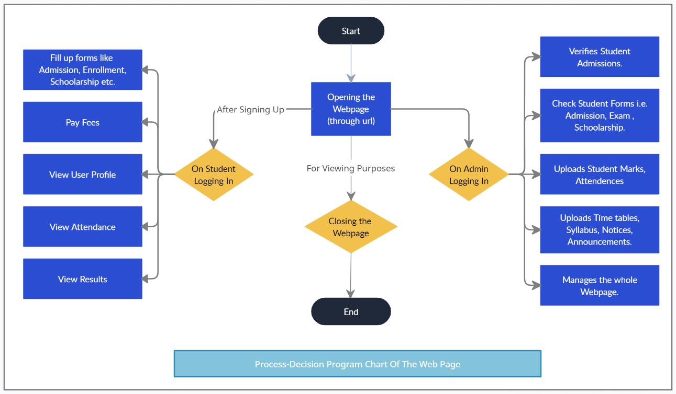

1. **Data Flow Diagram (DFD) :**

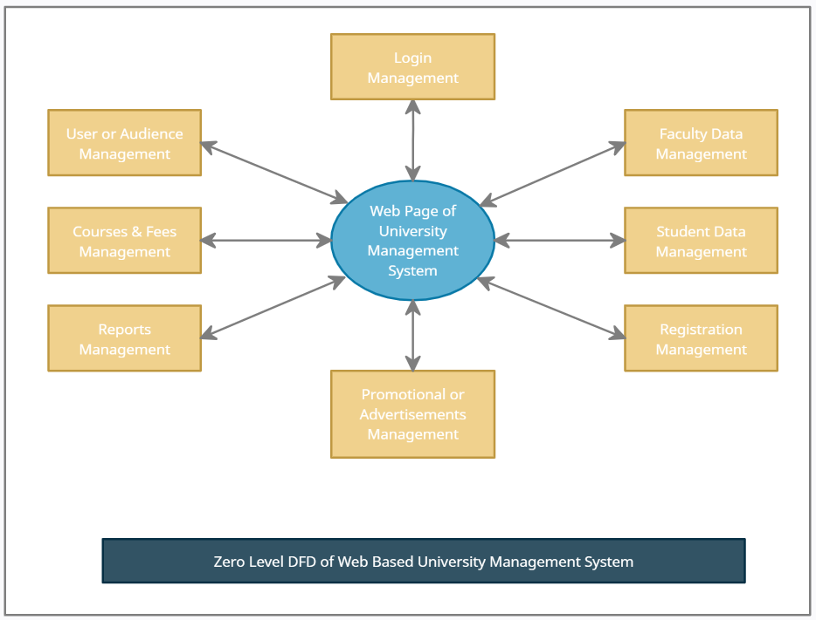

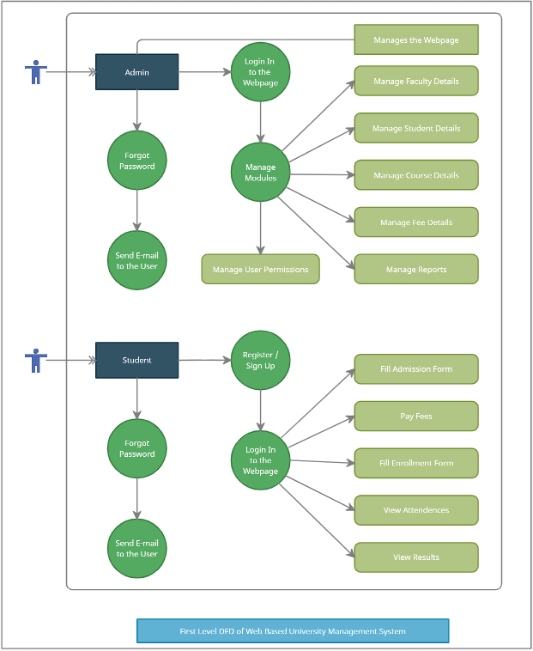

1. **E-R Diagram:**

